Open Zigzag Shapes
# Source: AI Source: Provided by: [Data Path: Persons Table -> ID Column: 1, Name_En Column: Motasem Essam] -> From: [ChatGPT] on [7/25/2026]
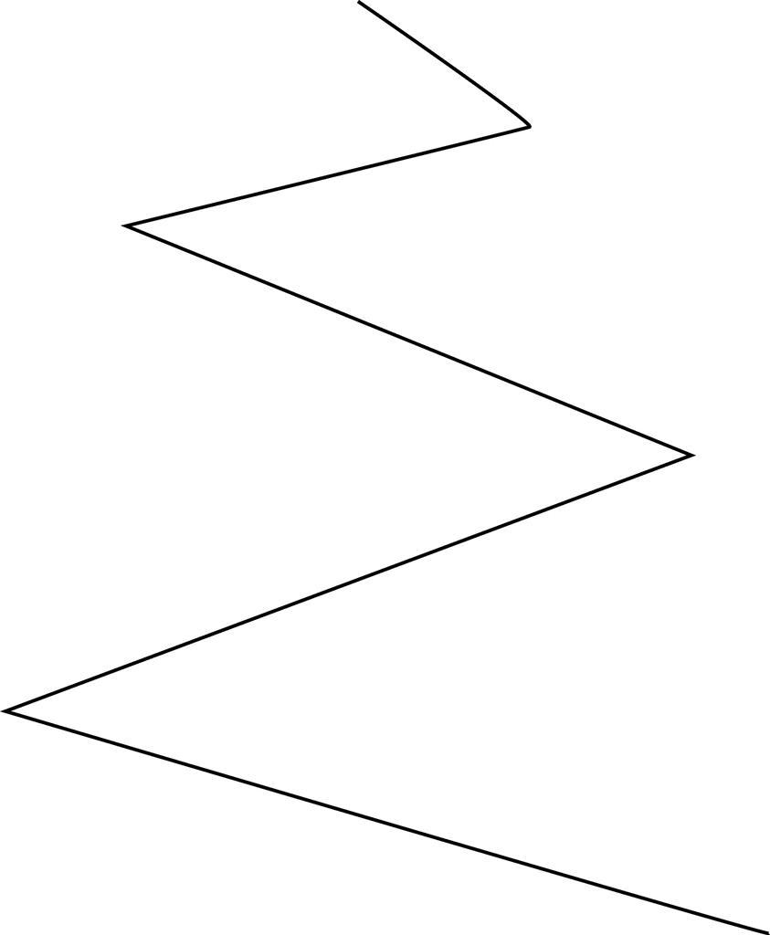
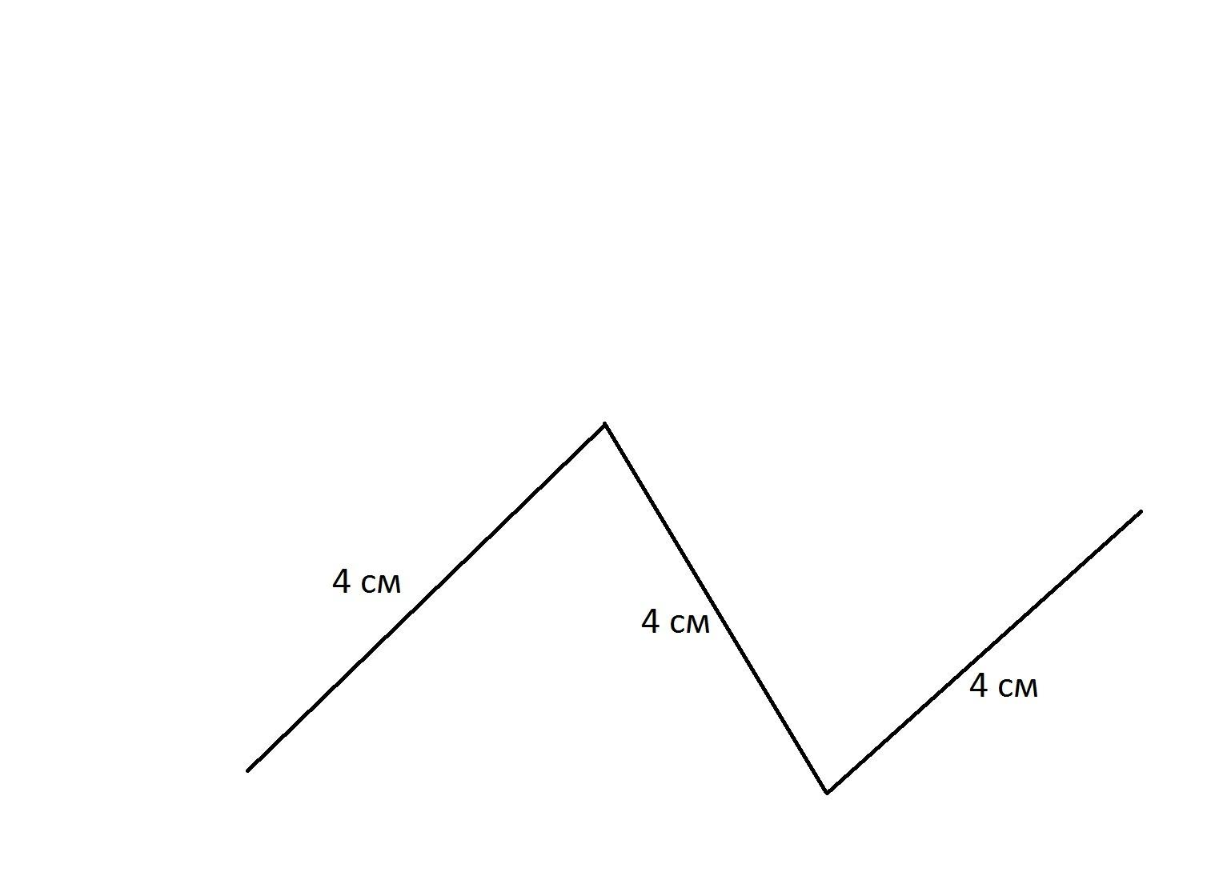
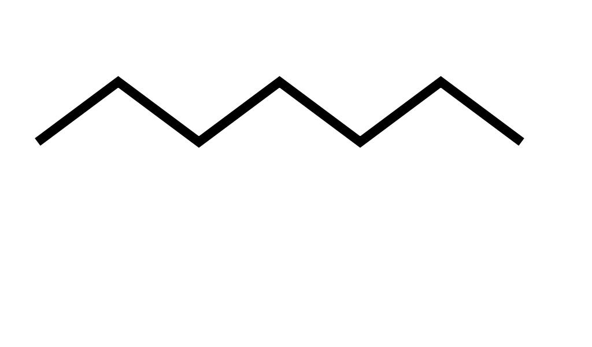

Definition
# Source: AI Source: Provided by: [Data Path: Persons Table -> ID Column: 1, Name_En Column: Motasem Essam] -> From: [ChatGPT] on [7/25/2026]
An Open Zigzag Shape is a zigzag form whose boundary or path consists of connected line segments that repeatedly change direction but does not form a closed boundary.
The two endpoints remain separate, so the shape does not enclose a region.

Fundamental Concept
# Source: AI Source: Provided by: [Data Path: Persons Table -> ID Column: 1, Name_En Column: Motasem Essam] -> From: [ChatGPT] on [7/25/2026]
An open zigzag is formed by connecting several line segments end-to-end while changing direction repeatedly.
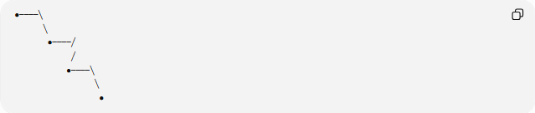
●────╲
╲
●────╱
╱
●────╲
╲
●
The path has:
- Two distinct endpoints
- Multiple connected segments
- Repeated changes in direction
- No enclosed interior region

Main Characteristics
# Source: AI Source: Provided by: [Data Path: Persons Table -> ID Column: 1, Name_En Column: Motasem Essam] -> From: [ChatGPT] on [7/25/2026]
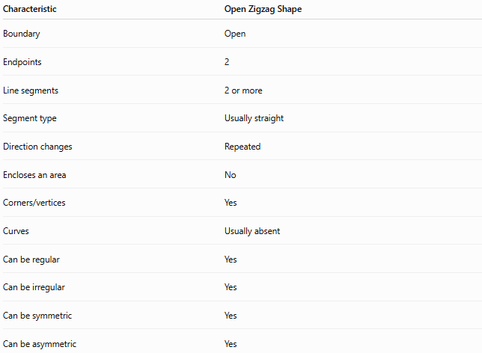
Characteristic | Open Zigzag Shape
Boundary | Open
Endpoints | 2
Line segments | 2 or more
Segment type | Usually straight
Direction changes | Repeated
Encloses an area | No
Corners/vertices | Yes
Curves | Usually absent
Can be regular | Yes
Can be irregular | Yes
Can be symmetric | Yes
Can be asymmetric | Yes

Basic Structure
# Source: AI Source: Provided by: [Data Path: Persons Table -> ID Column: 1, Name_En Column: Motasem Essam] -> From: [ChatGPT] on [7/25/2026]
An open zigzag can be represented by a sequence of connected points:
P₁ → P₂ → P₃ → P₄ → P₅
The segments are:
$$\overset{‾}{P_{1}P_{2}}, \overset{‾}{P_{2}P_{3}}, \overset{‾}{P_{3}P_{4}}, \overset{‾}{P_{4}P_{5}}$$
The first point $P_{1}$and the last point $P_{5}$are not connected.
Therefore, the path remains open.

Types of Open Zigzag Shapes
# Source: AI Source: Provided by: [Data Path: Persons Table -> ID Column: 1, Name_En Column: Motasem Essam] -> From: [ChatGPT] on [7/25/2026]
Open zigzag shapes can be further classified according to their pattern.
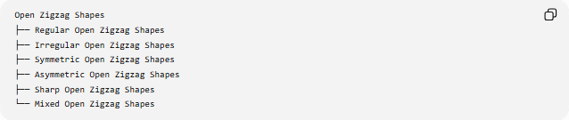
Open Zigzag Shapes
├── Regular Open Zigzag Shapes
├── Irregular Open Zigzag Shapes
├── Symmetric Open Zigzag Shapes
├── Asymmetric Open Zigzag Shapes
├── Sharp Open Zigzag Shapes
└── Mixed Open Zigzag Shapes

1-Regular Open Zigzag Shapes
# Source: AI Source: Provided by: [Data Path: Persons Table -> ID Column: 1, Name_En Column: Motasem Essam] -> From: [ChatGPT] on [7/25/2026]
A regular open zigzag follows a repeated pattern, such as equal or systematically repeating segment lengths and angles.
Example:
╱╲╱╲╱╲╱
The pattern repeats consistently.

2-Irregular Open Zigzag Shapes
# Source: AI Source: Provided by: [Data Path: Persons Table -> ID Column: 1, Name_En Column: Motasem Essam] -> From: [ChatGPT] on [7/25/2026]
An irregular open zigzag has segments or direction changes that do not follow a consistent pattern.
Example:
╱╲──╱╲╱────╲
The lengths and angles may vary.

3-Symmetric Open Zigzag Shapes
# Source: AI Source: Provided by: [Data Path: Persons Table -> ID Column: 1, Name_En Column: Motasem Essam] -> From: [ChatGPT] on [7/25/2026]
A symmetric open zigzag has a line or other symmetry relationship.
For example, a zigzag may have a mirror-symmetric arrangement around a vertical axis.

4-Asymmetric Open Zigzag Shapes
# Source: AI Source: Provided by: [Data Path: Persons Table -> ID Column: 1, Name_En Column: Motasem Essam] -> From: [ChatGPT] on [7/25/2026]
An asymmetric open zigzag has no corresponding symmetry under the transformation being considered.

5-Sharp Open Zigzag Shapes
# Source: AI Source: Provided by: [Data Path: Persons Table -> ID Column: 1, Name_En Column: Motasem Essam] -> From: [ChatGPT] on [7/25/2026]
A sharp open zigzag consists primarily of pronounced angular turns.
╱╲╱╲╱╲

6-Mixed Open Zigzag Shapes
# Source: AI Source: Provided by: [Data Path: Persons Table -> ID Column: 1, Name_En Column: Motasem Essam] -> From: [ChatGPT] on [7/25/2026]
A mixed open zigzag combines different segment lengths, directions, or patterns within the same open path.

Mathematical Properties
# Source: AI Source: Provided by: [Data Path: Persons Table -> ID Column: 1, Name_En Column: Motasem Essam] -> From: [ChatGPT] on [7/25/2026]
Number of Endpoints
Every non-closed open zigzag path has:
$$\boxed{2\text{ endpoints}}$$
Number of Segments
If an open zigzag contains $n$vertices, then the number of connected segments is:
$$\boxed{n-1}$$
For example:
P₁ ─ P₂ ─ P₃ ─ P₄ ─ P₅
has 5 vertices and:
$$5-1=4$$
segments.
Total Length
If the segment lengths are $l_{1},l_{2},…,l_{n}$, the total length is:
$$\boxed{L=l_{1}+l_{2}+⋯+l_{n}}$$
This is the path length, not the perimeter of an enclosed region.

Open Zigzag Shape vs. Closed Zigzag Shape
# Source: AI Source: Provided by: [Data Path: Persons Table -> ID Column: 1, Name_En Column: Motasem Essam] -> From: [ChatGPT] on [7/25/2026]
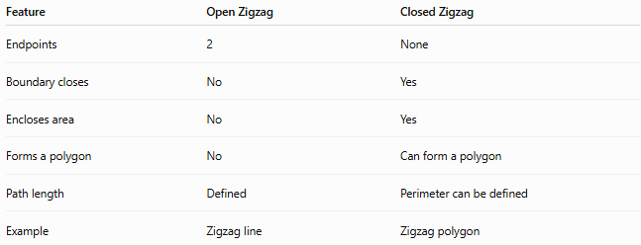
Feature | Open Zigzag | Closed Zigzag
Endpoints | 2 | None
Boundary closes | No | Yes
Encloses area | No | Yes
Forms a polygon | No | Can form a polygon
Path length | Defined | Perimeter can be defined
Example | Zigzag line | Zigzag polygon
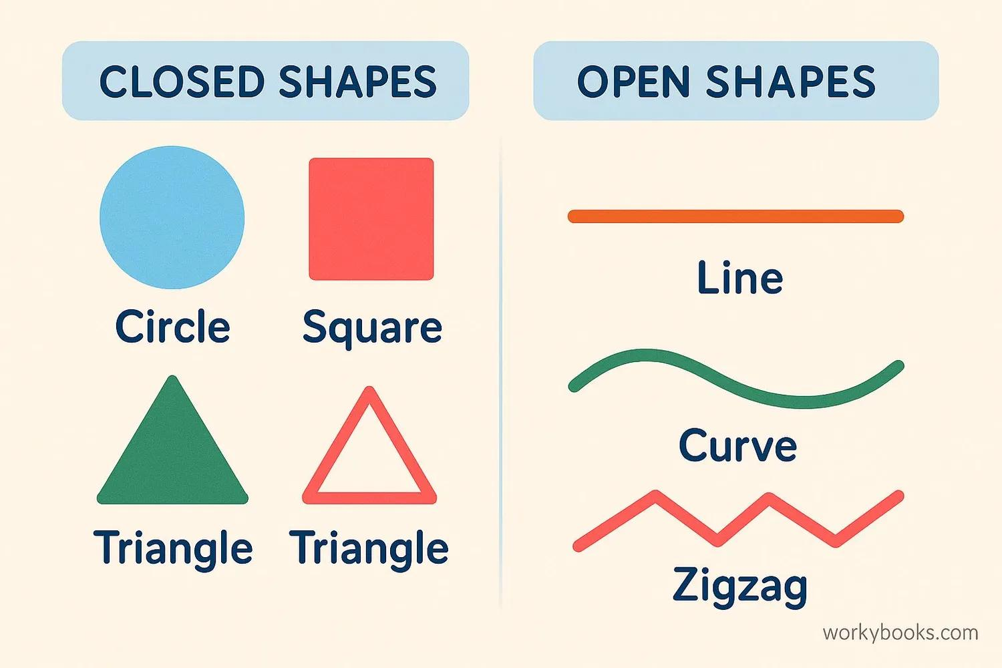
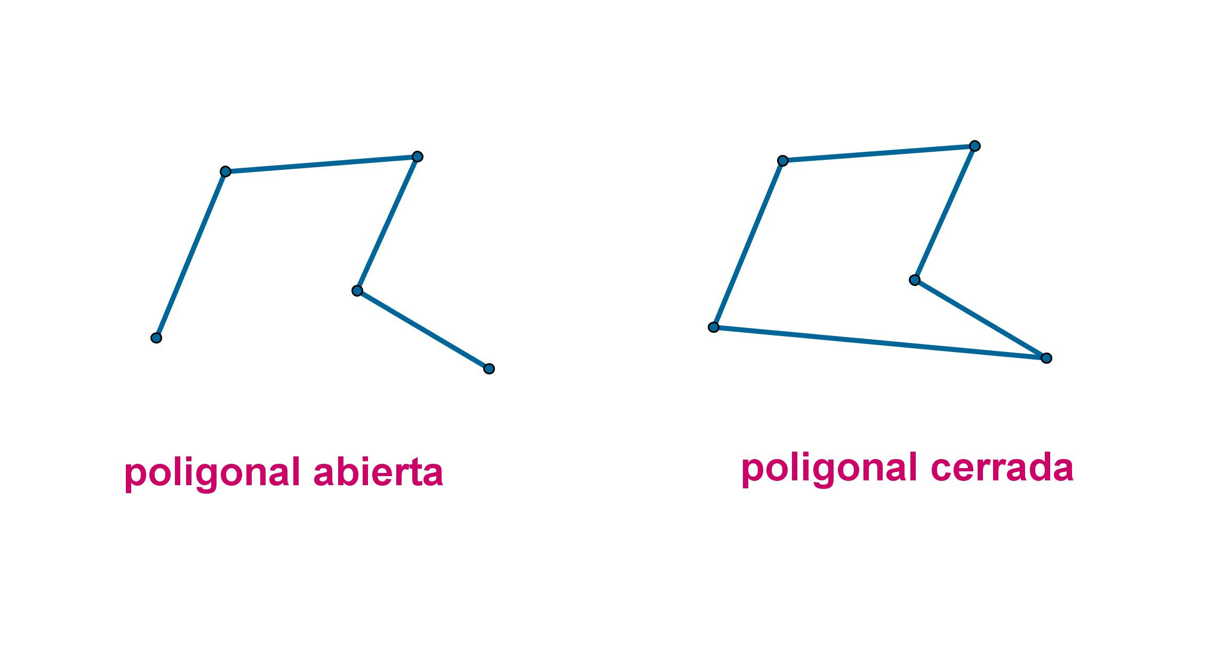
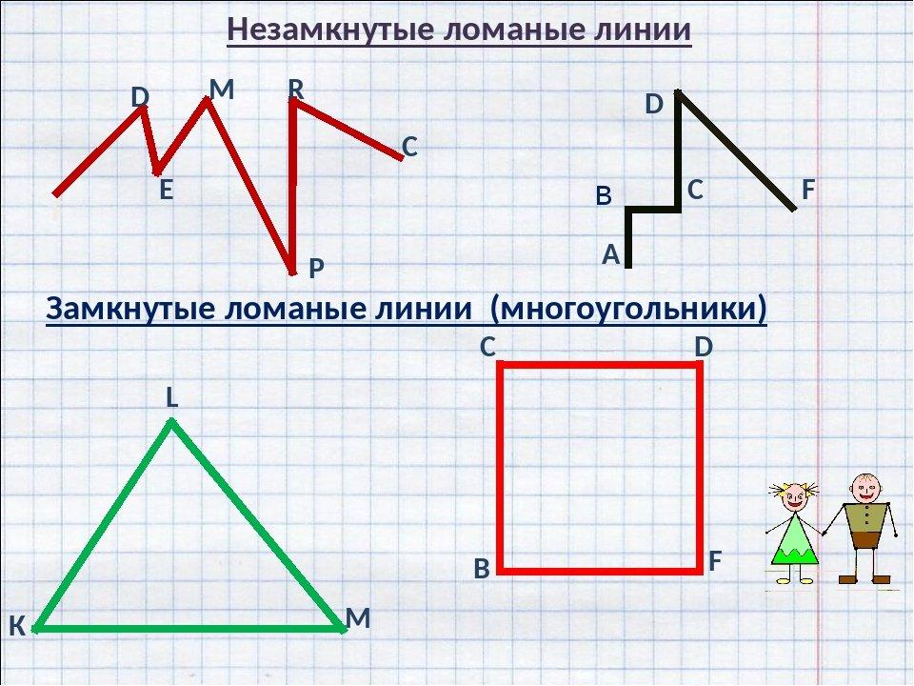

Open Zigzag Shape vs. Wavy Shape
# Source: AI Source: Provided by: [Data Path: Persons Table -> ID Column: 1, Name_En Column: Motasem Essam] -> From: [ChatGPT] on [7/25/2026]
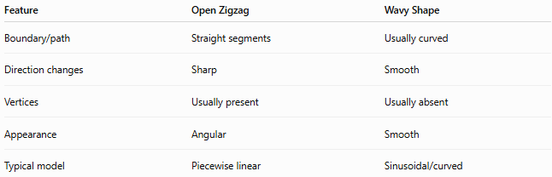
Feature | Open Zigzag | Wavy Shape
Boundary/path | Straight segments | Usually curved
Direction changes | Sharp | Smooth
Vertices | Usually present | Usually absent
Appearance | Angular | Smooth
Typical model | Piecewise linear | Sinusoidal/curved
An important distinction is that zigzag describes repeated angular changes, whereas wavy describes smooth, wave-like changes.

Examples

Example 1 – Simple Open Zigzag
# Source: AI Source: Provided by: [Data Path: Persons Table -> ID Column: 1, Name_En Column: Motasem Essam] -> From: [ChatGPT] on [7/25/2026]
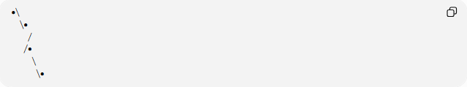
●╲
╲●
╱
╱●
╲
╲●
This is open because its endpoints are not connected.

Example 2 – Regular Open Zigzag
# Source: AI Source: Provided by: [Data Path: Persons Table -> ID Column: 1, Name_En Column: Motasem Essam] -> From: [ChatGPT] on [7/25/2026]
╱╲╱╲╱╲╱
The pattern repeats regularly.

Example 3 – Irregular Open Zigzag
# Source: AI Source: Provided by: [Data Path: Persons Table -> ID Column: 1, Name_En Column: Motasem Essam] -> From: [ChatGPT] on [7/25/2026]
╱╲──╱╲╱────╲╱
The segment lengths and turns vary.

Classification Summary
# Source: AI Source: Provided by: [Data Path: Persons Table -> ID Column: 1, Name_En Column: Motasem Essam] -> From: [ChatGPT] on [7/25/2026]
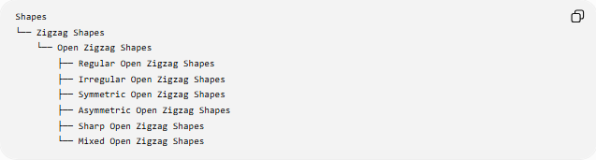
Shapes
└── Zigzag Shapes
└── Open Zigzag Shapes
├── Regular Open Zigzag Shapes
├── Irregular Open Zigzag Shapes
├── Symmetric Open Zigzag Shapes
├── Asymmetric Open Zigzag Shapes
├── Sharp Open Zigzag Shapes
└── Mixed Open Zigzag Shapes

Key Points
# Source: AI Source: Provided by: [Data Path: Persons Table -> ID Column: 1, Name_En Column: Motasem Essam] -> From: [ChatGPT] on [7/25/2026]
- An open zigzag shape is a zigzag path that does not close.
- It has exactly two endpoints.
- It is normally composed of straight line segments.
- Its segments repeatedly change direction.
- It does not enclose an area.
- Its total length is the sum of its segment lengths.
- It may be regular, irregular, symmetric, or asymmetric.
- A closed zigzag can form a polygon, while an open zigzag does not.

Conclusion
# Source: AI Source: Provided by: [Data Path: Persons Table -> ID Column: 1, Name_En Column: Motasem Essam] -> From: [ChatGPT] on [7/25/2026]
An Open Zigzag Shape is an open, angular path formed by connected straight-line segments that repeatedly change direction. Its defining property is that the path remains open, leaving two distinct endpoints and enclosing no region.

